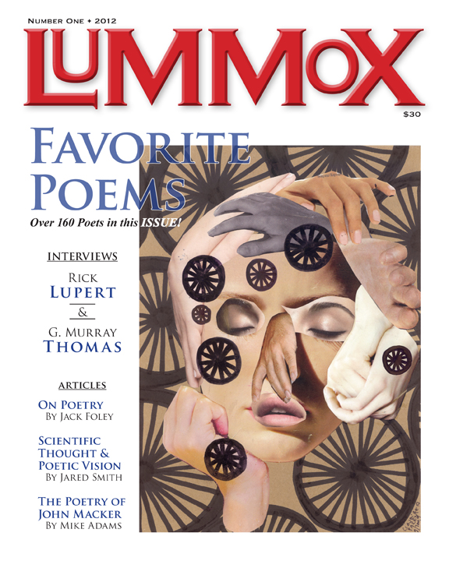

Found Art

To spot a diamond bit
among crushed beer cans
and rusty cars
is to find truth
in this man-made world.

Roseanna Frechette

Lummox Press announces the inaugural issue of a new annual magazine/anthology entitled LUMMOX, due out in Nov. of this year. The first issue has the work of over 160 poets in it and features SPECIAL SPOTLIGHTS on poetry from all over the US and beyond! Guest Editors Georgia Santa Maria (ABQ, NM), Jane Lipman (Santa Fe, NM), Biola Olatunde (Nigeria), Don Kingfisher Campbell (San Gabriel Valley, CA), Doug Holder (Boston area), Ed Nudelman (Academia), Jaimes Palacio (OC poets), Jane Crown (International), Marie Lecrivain (LA Poets), Mike Adams (Colorado area) and Ryan Guth (Mid-South) represent their areas with gusto! In addition to all this, the poetry from all over the US, Canada and the world is represented by both known and unknown poets. There are essays on poetry; reviews of poetry; 2 interviews with a couple of SoCal movers and shakers: G. Murray Thomas & Rick Lupert! There is also a Tributes section to fallen poets. On top of all this there is also artwork by Robert Branaman, Mark Hartenbach, Claudio Parentela, Norman Olson, James McGrath and Raindog. All this for just $25 (shipping included) when you buy direct from the Lummox Press website!
Reserve a copy at: www.lummoxpress.com/journal.html scroll to the bottom of the page for the Pay Pal button or directions to pay by check.

